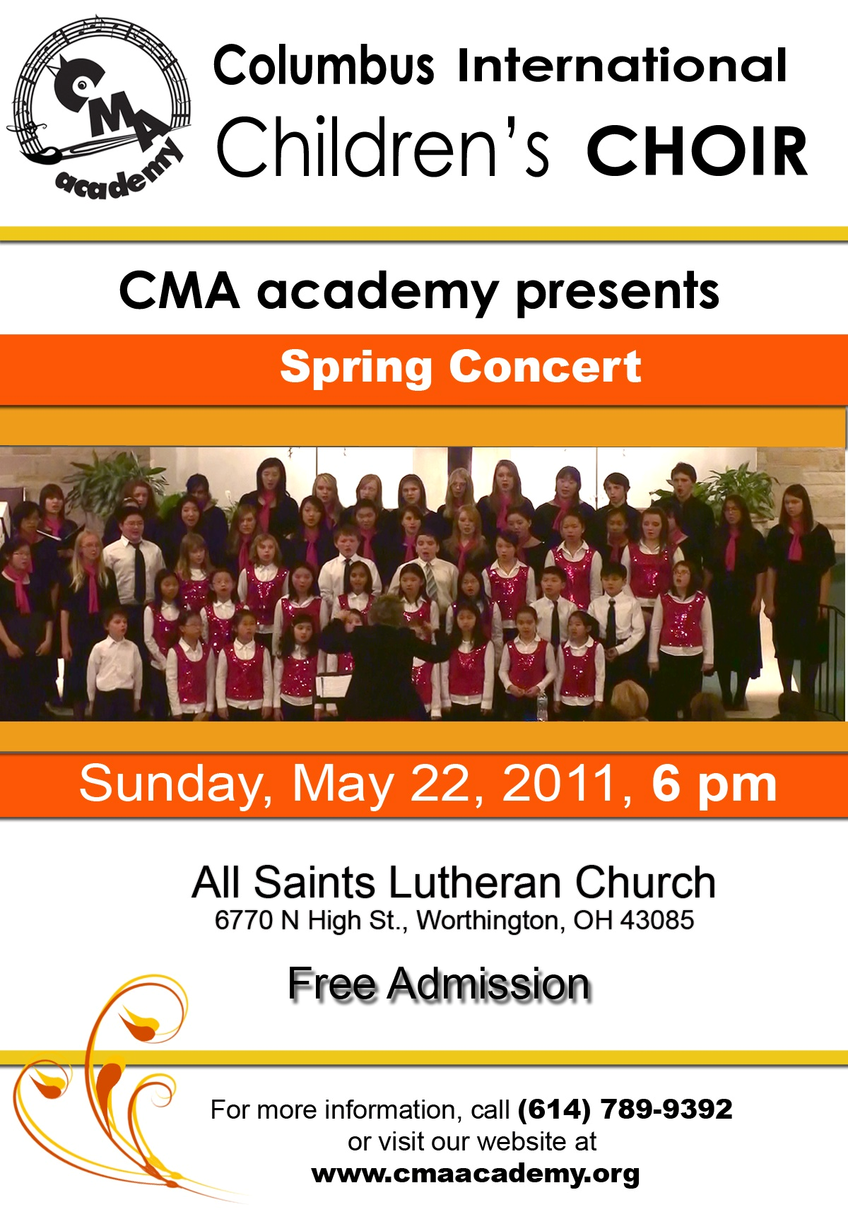
Holy Trinity Lutheran Church
2001 Northwest Blvd. Columbus, OH 43212

Winter Concert
December 11, 2011 6PM

